Adrianto Wijaya – 2301849441

Anselmus Pavel – 2301851414

Maximillian Michael – 2301854712

Jonathan Ricky – 2301899502

Hubertus Hans – 2301915821

Entity Relationship Diagram

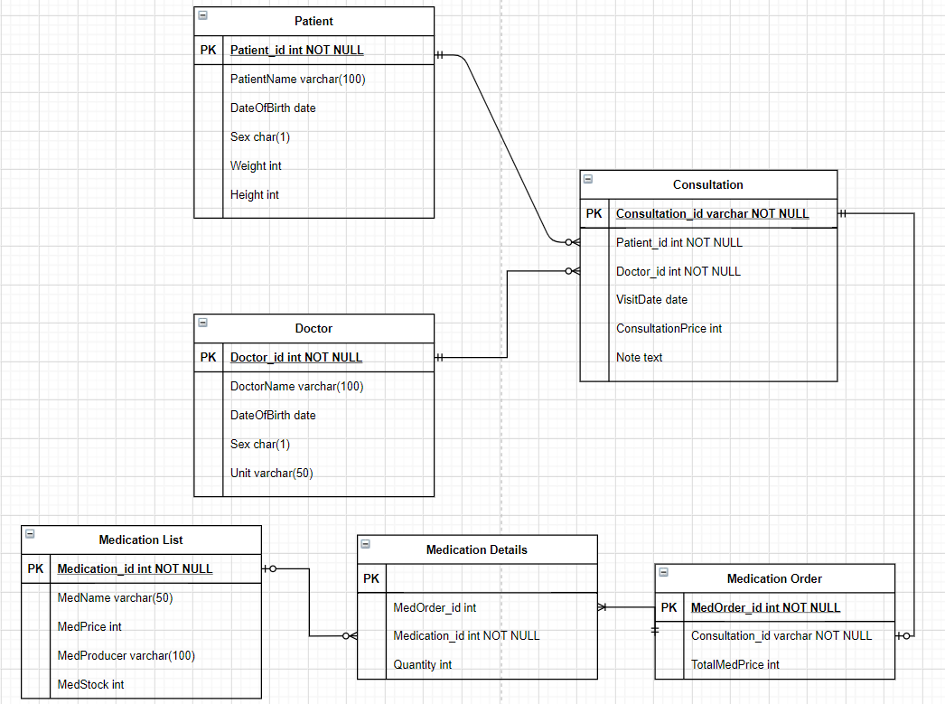

Data Flow Diagram

